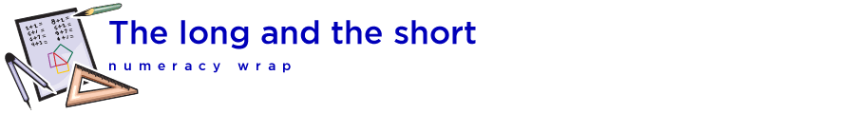

Teaching notes

This numeracy wrap addresses the following syllabus outcome from the NSW Mathematics K-10 Syllabus, May 2018, © Board of Studies, NSW:

Measurement and geometry
- MA3-9MG – selects and uses the appropriate unit and device to measure lengths and distances, calculates perimeters, and converts between units of length.

Students will:
- measure objects of different lengths in centimetres and millimetres
- order lengths from shortest to longest
- convert between millimetres, centimetres, metres and kilometres.

Task | Activities
Task 1 – Millimetres and centimetres | Measure the length of objects in centimetres using an interactive ruler.  Order lengths from shortest to longest by dragging and dropping given lengths shown in millimetres and centimetres.
Task 2 – Metres and kilometres | Use conversion rules to convert kilometres to metres and metres to kilometres.  Us a built-in quiz to practice the conversions.
Task 3 – Converting units of measurement | Revise the learning of the resource.  Use conversion rules to convert between millimetres, centimetres, metres and kilometres to complete the built-in quiz.

